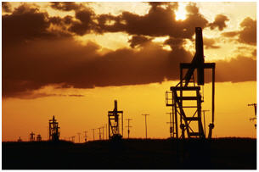
IFRS for Oil & Gas

Two-day industry training

Agenda
June 16-17, 2010
Day 1
7:00am – 8:30am Registration & Breakfast
8:30am – 9:00am Welcome/Poll/Survey
9:00am – 10:00am Key Note Speaker and Q&A –
Glenn Brady - International Accounting Standards Board
10:00am – 10:30am Break
10:30am – 12:00pm Breakout Sessions
UPSTREAM | MIDSTREAM | DOWNSTREAM
- Extractive Activities | - Property, Plant & Equipment | - Impairment
- Full Cost | - Property, Plant & Equipment

12:00pm – 1:00pm Lunch
1:00pm – 3:45pm Breakout Sessions
UPSTREAM | MIDSTREAM | DOWNSTREAM
- Revenue Recognition | - Joint Ventures | - Asset Retirement Obligations
- Property, Plant & Equipment | - Impairment | - Inventory
 |  | - Business Combinations
3:45pm – 4:00pm Break
4:00pm – 5:30pm Financial Instruments
6:00pm – 9:00pm Dinner

Day 2
7:00am – 8:30am Breakfast & Registration
8:30am – 9:30am Income Taxes
9:30am – 10:00am Break
10:30am – 12:00pm Breakout Sessions
UPSTREAM | MIDSTREAM | DOWNSTREAM
- Asset Retirement Obligations  - Impairment | - Rate Regulated Activities | - Property, Plant & Equipment

11:30am – 12:30pm Lunch
12:30pm – 1:00pm 2nd Poll/Survey
1:00pm – 3:15pm Breakout Sessions
UPSTREAM | MIDSTREAM | DOWNSTREAM
- Joint Ventures | - Asset Retirement Obligations | - Revenue Recognition
- Inventory | - Revenue Recognition | - Joint Ventures

3:15pm – 3:30pm Break
3:30pm – 4:15pm Plenary: Industry Update
4:15pm – 5:30pm To Be Determined

